Slip 1(a) Write an Angular 13 application addition of two numbers using ng-init, ng-model & ng-bind. And also demonstrate ng-show, ng-disabled, ng-click directives on button component.
a) ng new slip1
b) cd slip1
c) open app.component.ts
import { Component } from '@angular/core';

@Component({
selector: 'app-root',
templateUrl: './app.component.html',
styleUrls: ['./app.component.css']
})
export class AppComponent {
num1: number = 0;
num2: number = 0;
result: number = 0;
disableButton: boolean = false;
showResult: boolean = false;

add(): void {
this.result = this.num1 + this.num2;
this.disableButton = true; // Disable the button after calculation
this.showResult = true; // Show the computed result
}
}

2)app.component.html
<div>
<h2>Add Two Numbers</h2>
<label>
First Number:
<input type="number" [(ngModel)]="num1">
</label> <br>
<label>
Second Number:
<input type="number" [(ngModel)]="num2">
</label>
<br><br>

<button (click)="add()" [disabled]="disableButton">
Compute Sum
</button>
<br><br>

<h3 *ngIf="showResult">
Result: {{ result }}
</h3>
</div>

3) app.module.ts
import { NgModule } from '@angular/core';
import { BrowserModule } from '@angular/platform-browser';
import { FormsModule } from '@angular/forms';
import { AppComponent } from './app.component';

@NgModule({
declarations: [
AppComponent
],
imports: [
BrowserModule,FormsModule
],
providers: [],
bootstrap: [AppComponent]
})
export class AppModule { }

Run project -
ng serve -o

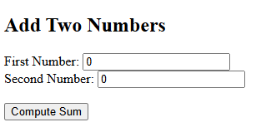

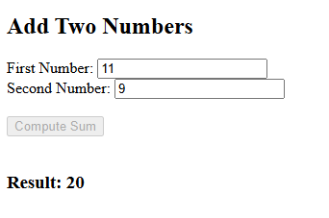

2) Write an AngularJS script to print details of bank (bank name, MICR code, IFC code, address etc.) in tabular form using ng-repeat.
import { Component } from '@angular/core';
interface Bank {
name: string;
micr: string;
ifsc: string;
address: string;
}
@Component({
selector: 'app-root',
templateUrl: './app.component.html',
styleUrls: ['./app.component.css']
})
export class AppComponent {
banks: Bank[] = [
{
name: 'HDFC',
micr: '123456789',
ifsc: 'FNB0001234',
address: 'Chinchwad'
},
{
name: 'SBI',
micr: '987654321',
ifsc: 'PTB0009876',
address: 'Pimpri'
},
{
name: 'TJSB',
micr: '987654323',
ifsc: 'TJB0009876',
address: 'Pune'
},
];
}
<div>
<h2>Bank Details</h2>
<table>
<thead>
<tr>
<th>Bank Name</th>
<th>MICR Code</th>
<th>IFSC Code</th>
<th>Address</th>
</tr>
</thead>
<tbody>
<tr *ngFor="let bank of banks">
<td>{{ bank.name }}</td>
<td>{{ bank.micr }}</td>
<td>{{ bank.ifsc }}</td>
<td>{{ bank.address }}</td>
</tr>
</tbody>
</table>
</div>

Add formsModule in app.module.ts
import { NgModule } from '@angular/core';
import { BrowserModule } from '@angular/platform-browser';
import { FormsModule } from '@angular/forms';
import { AppRoutingModule } from './app-routing.module';
import { AppComponent } from './app.component';

@NgModule({
declarations: [
AppComponent
],
imports: [
BrowserModule,
AppRoutingModule,FormsModule
],
providers: [],
bootstrap: [AppComponent]
})
export class AppModule { }

*************************************output-********************************************
ng serve -o
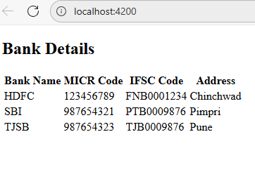

3) Find a company with a workforce greater than 30 in the array (use find by id method)
import { Component } from '@angular/core';
interface Company {
id: number;
name: string;
workforce: number;
}
@Component({
selector: 'app-root',
templateUrl: './app.component.html',
styleUrls: ['./app.component.css']
})
export class AppComponent {
companies: Company[] = [ { id: 1, name: 'Alpha Corp', workforce: 25 },
{ id: 2, name: 'Beta Ltd', workforce: 45 },
{ id: 3, name: 'Gamma LLC', workforce: 30 }
];
foundCompany?: Company;
findCompany(): void {
this.foundCompany = this.companies.find(c => c.workforce > 30);
}
}
app.component.html
<div class="container">
<h2>Company Search by Workforce</h2>
<button (click)="findCompany()">
Find Company with Workforce > 30
</button>
<div *ngIf="foundCompany; else notFound">
<h3>Found Company:</h3>
<p><strong>ID:</strong> {{ foundCompany.id }}</p>
<p><strong>Name:</strong> {{ foundCompany.name }}</p>
<p><strong>Workforce:</strong> {{ foundCompany.workforce }}</p>
</div>
<ng-template #notFound>
<p>No company found with workforce greater than 30.</p>
</ng-template>
</div>

*************************************output-********************************************
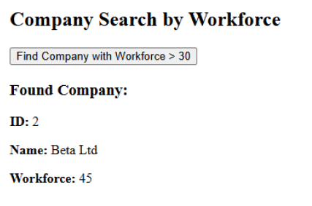

4) Write an Angular to display list of games stored in an array on click of
button using ng-click and also demonstrate ng-init, ng-bind directive of AngularJS.
app.component.ts
import { Component, OnInit } from '@angular/core';
@Component({
selector: 'app-root',
templateUrl: './app.component.html',
styleUrls: ['./app.component.css']})
export class AppComponent implements OnInit {
title = 'Angular 13 Game List';
games: string[] = [];
showGamesList = false;
constructor() {}
ngOnInit(): void {
// Initialize any default values here
this.games = []; // Empty by default
}
showGames(): void {
this.games = [
'Minecraft',
'Basketball',
'Football',
'kho-kho',
'Cricket'
];
this.showGamesList = true;
}
}
app.component.html
<h1>{{ title }}</h1>
<button (click)="showGames()">Show Games</button>
<ul *ngIf="showGamesList">
<li *ngFor="let game of games">{{ game }}</li>
</ul>

*************************************output-********************************************
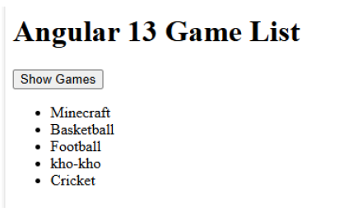

5) Create a simple Angular component that takes input data and displays it.
ng g c user
user.component.ts
import { Component, OnInit, Input } from '@angular/core';
@Component({
selector: 'app-user',
templateUrl: './user.component.html',
styleUrls: ['./user.component.css']
})
export class UserComponent implements OnInit {
@Input() userName!: string;
@Input() userEmail!: string;
constructor() { }
ngOnInit(): void {
console.log("Username:", this.userName);
console.log("User Email:", this.userEmail);
}
}
user.component.html
import { Component, OnInit, Input } from '@angular/core';
@Component({
selector: 'app-user',
templateUrl: './user.component.html',
styleUrls: ['./user.component.css']
})
export class UserComponent implements OnInit {
@Input() userName!: string;
@Input() userEmail!: string;
constructor() { }
ngOnInit(): void {
console.log("Username:", this.userName);
console.log("User Email:", this.userEmail);
}
}
app.component.ts
import { Component } from '@angular/core';
@Component({
selector: 'app-root',
templateUrl: './app.component.html',
styleUrls: ['./app.component.css']
})
export class AppComponent {
title = 'inputcomponent';
name = 'Soham kale';
email = 'soham.kale@example.com';
}
app.component.html
<h2>{{ title }}</h2>
<!-- Passing data to child component -->
<app-user [userName]="name" [userEmail]="email"></app-user>

*************************************output-********************************************
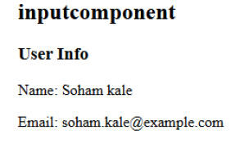

6) Create Angular 13application that print the name of students who got 85% using filter and map method.
app.component.ts

import { Component, OnInit } from '@angular/core';

interface Student {
name: string;
percentage: number;
}

@Component({
selector: 'app-root',
templateUrl: './app.component.html',
styleUrls: ['./app.component.css']
})
export class AppComponent implements OnInit {
students: Student[] = [
{ name: 'Ram', percentage: 90 },
{ name: 'Sunil', percentage: 85 },
{ name: 'Suresh', percentage: 82 },
{ name: 'Mona', percentage: 85 },
{ name: 'Sona', percentage: 78 },
];

studentsWith85: string[] = [];

ngOnInit(): void {
this.studentsWith85 = this.students
// filter those whose percentage is exactly 85
.filter(s => s.percentage === 85)
// then map to just the names
.map(s => s.name);
}
}

app.component.html
<h2>Students who got 85%</h2>
<ul>
<li *ngFor="let name of studentsWith85">{{ name }}</li>
</ul>

*************************************output-********************************************

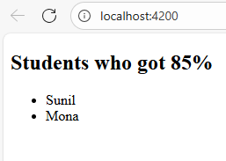

7) Fetch the details using ng-repeat in AngularJS
<!DOCTYPE html>
<html>

<head>
<script src=
"https://ajax.googleapis.com/ajax/libs/angularjs/1.6.9/angular.min.js">
</script>
<title>
Fetching the details using the ng-repeat Directive
</title>
<style>
body {
text-align: center;
font-family: Arial, Helvetica, sans-serif;
}

table {
margin-left: auto;
margin-right: auto;
}
</style>
</head>

<body ng-app="myTable">
<h1 style="color:green">GeeksforGeeks</h1>
<h3>
Fetching the details using the ng-repeat Directive
</h3>

<table ng-controller="control" border="2">
<tr ng-repeat="x in records">
<td>{{x.Country}}</td>
<td>{{x.Capital}}</td>
</tr>
</table>

<script>
var app = angular.module("myTable", []);
app.controller("control", function ($scope) {
$scope.records = [
{
"Country": "India",
"Capital": "Delhi"
},
{
"Country": "America ",
"Capital": "Washington, D.C. "
},
{
"Country": "Germany",
"Capital": "Berlin"
},
{
"Country": "Japan",
"Capital": "Tokyo"
}
]
});
</script>
</body>
</html>

*************************************output-********************************************
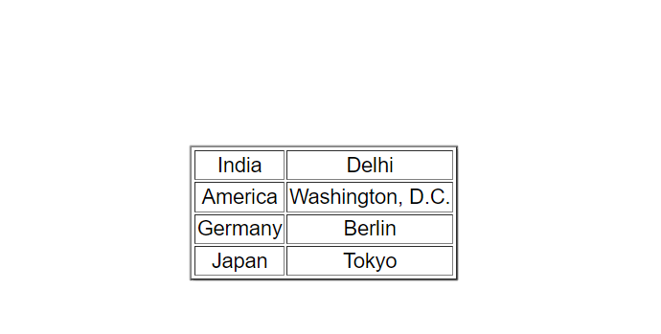

8) Create a Node.js application that reads data from multiple files asynchronously using promises and async/await
// Import the 'fs/promises' module for asynchronous file system operations
const fs = require('fs').promises;

// Asynchronous function to read multiple files
async function readFiles(filePaths) {
try {
// Read all files asynchronously using Promise.all
const fileContents = await Promise.all(
filePaths.map(file => fs.readFile(file, 'utf8'))
);

// Display content of each file
fileContents.forEach((content, index) => {
console.log(`\n📄 Contents of file ${index + 1} (${filePaths[index]}):`);
console.log(content);
console.log('-----------------------------');
});

} catch (error) {
console.error("❌ Error reading files:", error.message);
}
}

// Define the file paths (make sure these files exist in your directory)
const files = ['file1.txt', 'file2.txt', 'file3.txt'];

readFiles(files);

*************************************output-********************************************
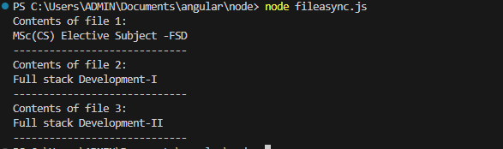

9) Implement a simple server using Node.js.
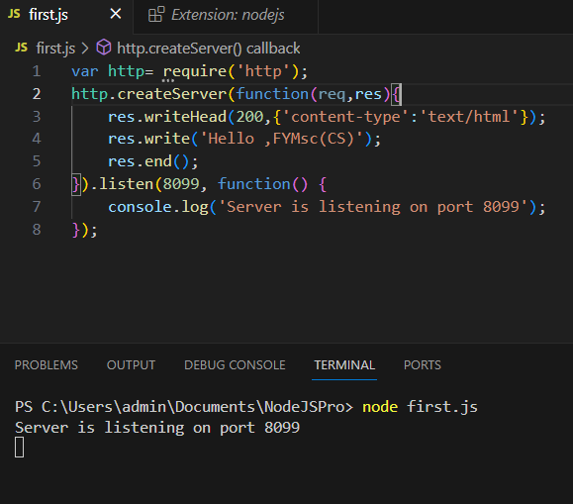

10) Develop an Express.js application that defines routes for Create, Update operations on a resource (Employee).
app.use(express.json());
let employees = [
{
id: 1,
name: 'Suman',
position: 'Developer', salary: 50000
}
];
let nextEmployeeId = 2;

// CREATE a new employee
// POST /employees
// Body expected: { name: string, position: string, salary: number } app.post('/employees', (req, res) => {
const { name, position, salary } = req.body;

// Validate input
if (!name || typeof name !== 'string') {
return res.status(400).json({ success: false, message: 'Name is required and must be a string' });
}
if (!position || typeof position !== 'string') {
return res.status(400).json({ success: false, message: 'Position is required and must be a string' });
}
if (salary === undefined || typeof salary !== 'number') {
return res.status(400).json({ success: false, message: 'Salary is required and must be a number' });
}
const newEmployee = {
id: nextEmployeeId++, name,
position, salary
};
employees.push(newEmployee);

res.status(201).json({ success: true, data: newEmployee });
});

// UPDATE an existing employee
// PUT /employees/:id
// Body can include name, position, salary (one or more) app.put('/employees/:id', (req, res) => {
const id = parseInt(req.params.id, 10); if (isNaN(id)) {
return res.status(400).json({ success: false, message: 'Invalid employee ID' });
}

const employee = employees.find(emp => emp.id === id); if (!employee) {
return res.status(404).json({ success: false, message: 'Employee not found' });
}

const { name, position, salary } = req.body;

// Validate each field if present if (name !== undefined) {
if (typeof name !== 'string') {
return res.status(400).json({ success: false, message: 'Name must be a string' });
}
employee.name = name;
}
if (position !== undefined) {
if (typeof position !== 'string') {
return res.status(400).json({ success: false, message: 'Position must be a string' });
}
employee.position = position;
}
if (salary !== undefined) {
if (typeof salary !== 'number') {

return res.status(400).json({ success: false, message: 'Salary must be a number' });
}
employee.salary = salary;
}
res.json({ success: true, data: employee });
});
// Optional: GET to view all or one employee app.get('/employees', (req, res) => {
res.json({ success: true, data: employees });
});
// Start server const PORT = 3000;
app.listen(PORT, () => {
console.log(`Employee API running on port ${PORT}`);
});

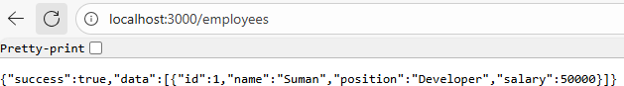

*************************************output-********************************************
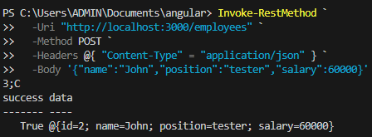

Update request
